请任选300-500单词试译
译文格式：中英文对照，一段（数行）原文之后紧接着一段（数行）译文。

STANDARD OF OPERATIONS
TASK | REGULAR CIGAR SERVICE
Department | Customer Services
Position | All Team Members
Position Code | 152023, 152021
Location/Outlet | Butler Department
Issue Date | 11 September 2010
Task Code | NGO/CS/JT098
Standard Statement
To ensure that each and every Team Member in the department performs the highest standards of Cigar service this procedure must be followed.
______________________________________________________________________________________
Equipment and materials
- Guillotine Cutter
- Cigar Stand
- Cigar Ashtray
- Butane Lighter
- Wooden Matches (Long)
PROCEDURE/STEPS | STANDARDS
- Present the Humidor Box.  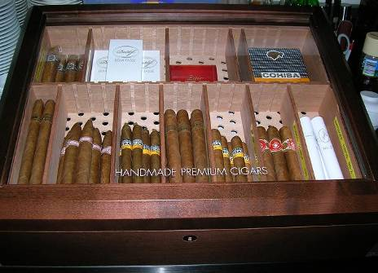  - In a comfortable position/angle easy for the guest to look and see all available cigars.  - Allow the guest ample time to choose the desired cigar  - When guest is ready to order listen carefully while taking the order | - Presenting to be done:  - Guest able to see all available cigars  - Don’t rush the guest/s  - Be able to answer questions / cigar knowledge
- After the guest has chosen the cigar he desired:  - Collect the cigar from the box or humidor  - Unwrap the cellophane of the cigar or remove from the tube (if applicable) | - Carefully handle the cigar avoiding any damages to it.
- Place the cigar on the cigar stand.
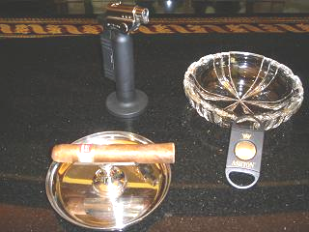
- Return the cigar to the guest offering him to cut and light the cigar | - Verbiage: “Excuse me Sir/ Madame/Guest Name, your cigar please; would you like me to cut the cigar for you?”  - If the guest prefers to cut it himself leave the Cigar Match beside the Cigar Stand.
- If the guest agrees to your offer begin cutting the cigar accordingly  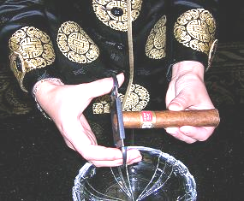 | - Offered cuts are:  - Small Cut; approximately length of cut is 2.5mm  - Medium Cut; approximately length of cut is 5.0mm  - Large Cut; approximately length of cut is 7.5mm  NOTE:  The area the cap is connecting with the wrapper is called “shoulder”. The best guideline in cutting the cigar is to make the cut slightly above the shoulder.  Refer to the diagram of RECOMMENDED CUT OF CIGAR
- Prepare the cigar and the cutter then precede cutting.  - See the CLIPPING THE CIGAR | - Place the cigar cutter in your right hand and the cigar into your left hand (holding it just below the label).
- Carefully cut the cigar at the appropriate location and size. | - Slightly above the horizontal line where the cap connects with the wrapper.  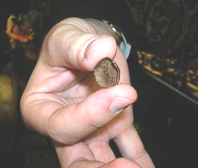
- After cutting the cigar offer the guest to light the cigar, | - Verbiage: “Sir/Madame/Guest Name, would you like me to light the cigar for you?”
- If the guest agrees hold the cigar.  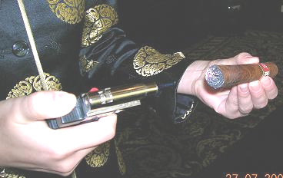 | - Holding the cigar at 45 degree (pointing downwards).  - With Team Member’s left fingers just below the label.
- Lighting the cigar:  - Slowly rotate the cigar to the foot of the cigar toasted all the way around  NOTE:  This will soot up your wrapper  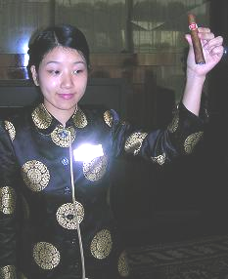 | - Using a butane lighter or cigar matches (long).  - Flame must not touch the cigar as it will char, producing a harsh taste.
- Hand over the cigar to the guest on the cigar stand (if applicable).  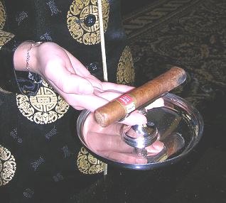 | - Verbiage: “Sir/Madame/Name of Guest, would you mind puffing the cigar gently please”?  - Advise the guest to rotate the cigar  NOTE:  Rotating the cigar will get an even burn and ensure flavourful first puff.  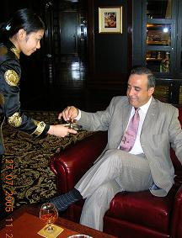
- While the guest is puffing the cigar hold the butane lighter or matches under the foot of the cigar. | - Remain standing in front of the guest while the guest is puffing the cigar.  - Do not allow the flame to touch the cigar  REASON:  The fire would leap to the cigar and ignite the entire circumference.  See LIGHTING A CIGAR
- Thank and leave the guest.   | - Verbiage: “Please enjoy your cigar, Sir/Madame/Guest Name”.

